Fairchild Reservation Systems

Functional Specifications Document

Version 1.0

Copyright 2011 Alex Fairchild

Revision History
Author | Version | Date | Description
Alex Fairchild | 1.0 | June 19, 2011 | Initial version

Table of Contents
Revision History 2
Table of Contents 2
Introduction 3
Specifications 3
Home Page 3
Flight Search 4
Availability Display 5
Hotels 7
Contact 7
Confirm 8
Itinerary 9

Introduction
This document defines the Functional Specifications for the Fairchild Reservation System. It aims to define how the requirements in the associated BRD will be actually implemented. The system will be a simple, web-based Airline and Hotel reservation system, that will allow a user to search for flight availability, make a flight reservation, and add hotel stay.

Specifications

Home Page
The home page will show a header with the company logo. There will be a search box on the upper left.
Across the top is a progress bar of where you are in the Reservation flow
Flights | Hotel | Contact | Confirm
- Items not yet arrived at are dark red.
- Current section will be Blue
- Done sections will be Green.
- These are not navigation, you can’t click them to go there, you have to use the ‘back’ buttons in the main section

To the right of the search will be a main section, when page is default it shows a Route Map, with all possible routes between San Francisco , Miami, New York, and Santo Domingo.
- Original all lines are dark, faded blue.
- When a city is selected for departure, all lines out of that city are shown thicker, dark blue.
- when a destination city is selected, the line is shown bright blue and all other lines are gone.
- This defines 10 separate line graphics
  - All cities light blue
  - MIA to other 3 dark blue
  - NYC to other 3 dark blue
  - SFO to NYC,MIA dark blue
  - SDQ to NYC, MIA dark blue
  - MIA/NYC bright blue
  - MIA/SFO bright blue
  - MIA SDQ bright blue
  - SFO NYC bright blue
  - NYC SDQ bright blue

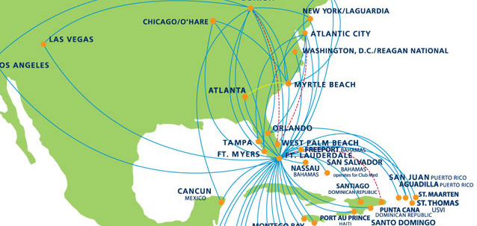

Flight Search
On the upper left there will be a search box,
- departure pulldown.
  - This will be active by default.
  - It will be populate with the four cities.
  - Initial value will read ‘select.
- Arrival pulldown
  - inactive by default
  - once a departure is selected, the possible arrivals will be displayed
    - MIA – other 3
    - JFK – other 3
    - SFO – MIA/JFK
    - SDQ – MIA/FJK
- Departure Date
  - Calendar only control
  - minimum date is tomorrow
  - active by default
- Arrival date
  - inactive till departure is picked
  - minimum date is departure date + 2
  - if one way checkbox is picked, this is disabled
- one way/ round trip radio buttons
  - default to round trip
  - if one way is checked, arrival date is disabled
- Number of passengers pulldown (1 -5)
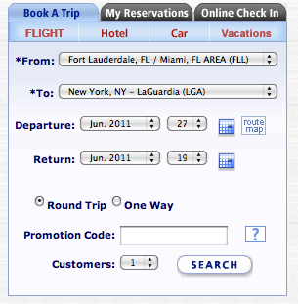

Availability Display
After the user hits ‘Search’, the route map fades out while fade in to the availability of the Outbound flights. For the Avail itself,
- there are tabs across the top showing 3 days back, and 3 days forward, the center tab reads ‘Departure’, and date. No price
- the cheapest fare on that date displayed.
- clicking on that tab slides the display left or right, now centered on that day, with 3 new lefts and right. (if sliding doesn’t look good from jQuery out of the box, then fade out/in)

Below the tabs is a list of flights,
- 3 flights per city pair in the system, Morning, noon, and Evening.
- internal inventory is 5 seats in first class, 20 in coach.

For each flight row,
- 2 prices, a Coach on the left, First Class on the right
- if there is no availability for that fare, that fare class is not shown at all, but the alignment is the same, so First class is always on Right.
- if no availability at all, flight does not show at all
- There are radio buttons next to each fare, none selected at first
- if a radio button is selected, the other flights become greyed out, and a highlight border appers on this flight.

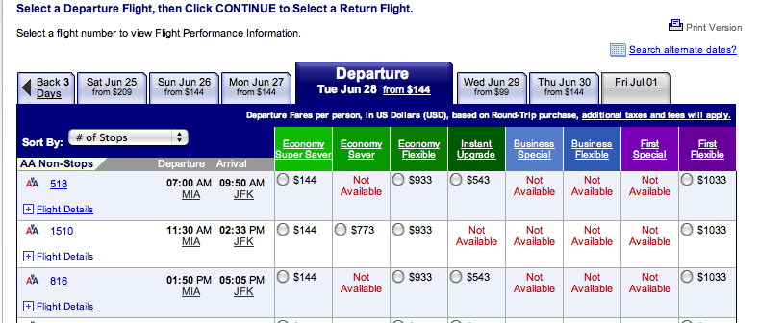
There is a button below the flights, labeled either ‘next’ or ‘select Return Flight’, depending on oneWay / Round Trip selection.
- Button is inactive by default.
- selecting a Fare enables button.
- The display will fade in and out and show the same display with the Returns – the main Tab shows ‘Return’
- The bottom button is now labeled ‘Next’ and is disabled.
- The user will again select a flight and fare, and the ‘Next’ button becomes active.
- Clicking on the ‘Next’ button fades out the Flight list, and a dialog appears saying ‘Would you like to add a Hotel to this reservation?’ clicking ‘Yes’ goes to Hotels list, ‘No’ goes directly to Contact.

Hotels

Next the display changes to a list of hotels.
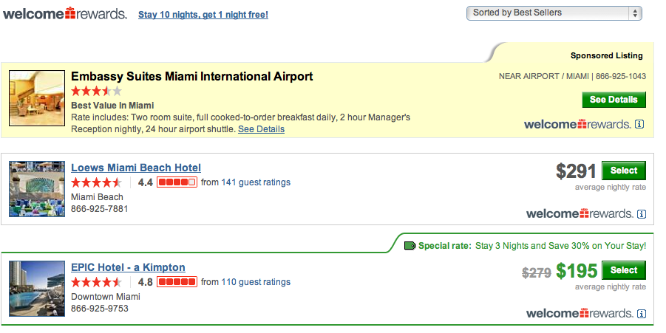
- 4 hotels per city pair,
- For each hotel
  - a pretty picture,
  - star rating,
  - description
  - rate per night,

There is a ‘Skip Hotel’, and ‘Next’ button below the hotel list.
- ‘Next’ button is disabled until hotel is picked.
- ‘Skip Hotel’ button is enabled and reddish

Contact
The main area now shows the Contact information page.
At the top we have the charges so far;
- base fare,
- taxes ,
- fuel surcharge,
- hotel reservation cost.

There are input fields for
- Name and Last name,
- telephone number,
- email address,
- birthday with three pulldowns for day/month/year

If there are more than 1 passenger
- for each passenger, a “passenger nnn” name and last name input field will be displayed
- Error validation of the fields will be enabled. All are required.

Confirm
Nex the Itinerary, Hotel, and contact information are displayed in three sections, each with a small ‘change’ button next to it. Below that the “Final Charges’ section, same as ‘charges so far’.
Change itinerary Takes you back to outbound flight selection.
- existing outbound itin is selected
- after confirming outbound, same return is selected
- if dates changed, system takes you to Hotel selection again
  - hotel is not selected
- if dates did not change, system goes from confirm Return back to ‘Confirm’ page

Change Hotel Takes you Select Hotel section
- existing hotel is selected

Change Contact goes back to Profile section
- contact data is prefilled

Below the sections to review, will be a form of payment section,
- type of credit card pulldown
- cc number input
- expiration date month pulldown, year pulldown
- cvvwhere you enter a fake credit card number,

Itinerary
When the user clicks confirm, they are taken to a nice printable itinerary with their.
- has a Print button right on the page.
- all alpha PNR.
- How much they paid, and what the form of payment was
- last four digits of cc.
- Some advice about getting to the airport 2 hours before flight time and have proper ID.
- Email is sent with same document

